Types of Reactions

Chemical reactions can be categorized into a variety of types. Five common types that we will study are synthesis, decomposition, combustion, single replacement and double replacement. Be familiar enough with the description of each type so that you are able to classify a reaction if given a chemical equation or verbal description.
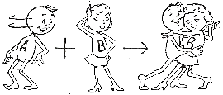
Synthesis:
Synthesis reactions involve the formation of more complex compounds (many atoms) from simpler compounds and/or elements. The most common synthesis reaction involves the formation of a compound from its elements.
Examples:
- H_{2(g)} + O_{2(g)} → 2 H₂O_{(g)}
- H_{2(g)} + N_{2(g)} → 2 NH_{3(g)} General: A + B → AB
Synthesis reactions are also referred to as combination, formation, and addition reactions.
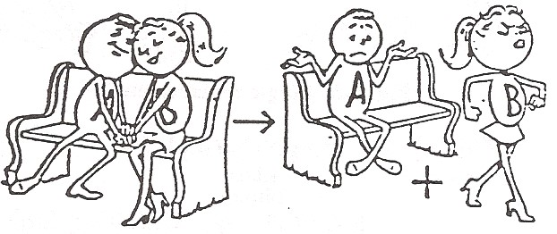
Decomposition:
Decomposition reactions involve the breaking down of more complex compounds (larger, more atoms) into simpler compounds and/or elements. These reactions can often be thought of as being the opposite of synthesis reactions. Decomposition reactions often require heating in order to occur.
Examples:
2 H₂O_{(l)} → 2 H_{2(g)} + O_{2(g)}
2 KClO_{3(s)} → 2 KCl_{(s)} + 3 O_{2(g)} General: AB → A + B
Combustion:
Combustion reactions involve the reaction of a substance with oxygen gas (O₂). It is often referred to as burning. The products of the reaction are oxides of the elements in the reactants. Hydrocarbon combustion leads to the formation of carbon dioxide gas and water vapor.
Examples:
2 Mg_{(s)} + O_{2(g)} → 2 MgO_{(s)}
CH_{4(g)} + 2 O_{2(g)} → CO_{2(g)} + 2 H₂O_{(g)} General: AB + O_{2(g)} → A_{x}O_{y} + B_{w}O_{z}
Some combustion reactions are also synthesis reactions. For instance, the combustion of magnesium leads to the formation of magnesium oxide.

Single Replacement:
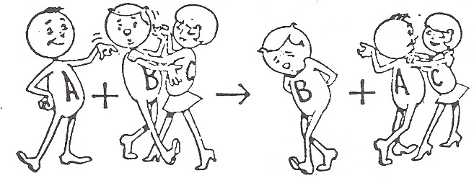
Single replacement reactions involve the reaction of an element with an ionic compound. The single element replaces one of the ions in the compound. If the lone element is a metal, then it will replace the positive ion in the compound. If the lone element is a nonmetal, then it will replace the negative ion.
Examples:
2 Al_{(s)} + 3 CuCl₂ _{(aq)} → 3 Cu_{(s)} + 2 AlCl₃ _{(aq)}
2 NaCl_{(s)} + F_{2(g)} → Cl₂ _{(g)} + 2 NaF_{(s)}
General: A + BC → AC + B (if A is a metal) A + BC → BA + C (if A is a nonmetal)
Single replacement reactions are also referred to as single displacement reactions.

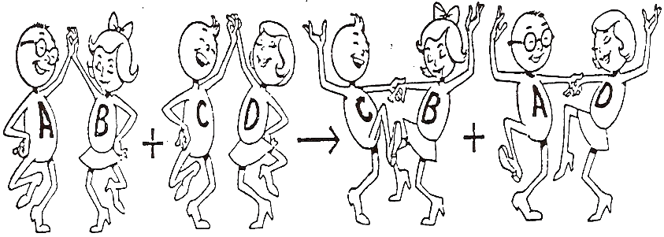
Double Replacement:
Double replacement reactions involve the reaction of two ionic compounds to form two different ionic compounds. The positive ion in one compound replaces the positive ion in the other compound.
Examples:
2KI_{(aq)} + Pb(NO₃)_{2(aq)} → PbI_{2(s)} + 2 KNO_{3(aq)}
HCl_{(aq)} + NaOH_{(aq)} → NaCl_{(aq)} + H₂O_{(l)}
General: AB + CD → AD + BC
Double replacement reactions are also referred to as double displacement reactions, and less commonly as metathesis reactions.
Many double replacement reactions involve the formation of a precipitate. The two reactants and one of the products are aqueous solutions of ionic salts and the other product is an ionic salt that is not soluble in water. It is seen as a precipitating solid. This is sometimes termed a precipitation reaction.
Some double replacement reactions involve the reaction of an acid with a base; these are a special case of double replacement reactions known as acid-base neutralization reactions.

REVIEW: TYPES OF CHEMICAL REACTIONS

- Read the definitions below. Then write the key term for each one in the left column.
  - _________________________ A reaction in which one element replaces another in a compound.
  - _________________________ A reaction in which two or more substances combine to form a new compound.
  - _________________________ A reaction in which a substance reacts with oxygen to produce thermal and light energy
  - _________________________ A reaction in which the positive ion on one compound replaces the positive ion of another compound.
  - _________________________ A reaction in which one substance breaks down into two more substances.

- Examine the diagram and identify what type of chemical reaction each set of symbols represent.

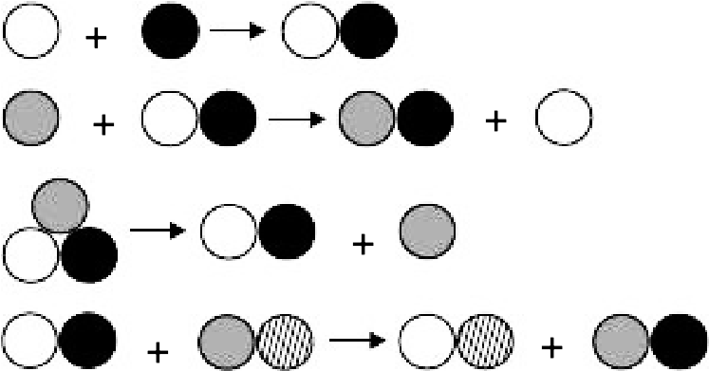
  - _________________________
  - _________________________
  - _________________________
  - _________________________

- Classify each chemical reaction by writing the reaction type in the blank to the left. Then, balance the reaction
  - _________________________ ___ Al + ___ O₂ → ___ Al₂O₃
  - _________________________ ___ HgO → ___ Hg + ___ O₂
  - _________________________ ___ NaOH + ___ H₂SO₄ →  ___ Na₂SO₄ + ___ H₂O
  - _________________________ ___ Fe + ___ O₂ → ___ Fe₂O₃
  - _________________________ ___ Pb(NO₃)₂ + ___ K₂(CrO₄) → ___ PbCrO₄ + ___ KNO₃
  - _________________________ ___ H₂ + ___ N₂ → ___ NH₃
  - _________________________ ___ Fe + ___ CuCl₂ → ___ FeCl₂ + ___ Cu
  - _________________________ ___ KClO₃ → ___ KCl + ___ O₂
  - _________________________ ___ Mg + ___ HCl → ___ H₂ + ___MgCl₂
j. _________________________ ___ C₃H₅(NO₃)₃ → ___ CO₂ + ___ N₂ + ___ H₂O + ___ O₂

